**International Trade**

Organic Market

Based on market data at 2012, although organic products are now produced in the four corner of the world, the number of demand still concentrate in two regions, Europe and United States. In 2012 Europe and US has entered a historic trade arrangement for organic food. Changing consumer demands is another challenge. International trading of organic food has grown from almost nothing into over US60 billion over 30 years. Economic stability also another major challenge. The financial crisis in 2008 also give impact to the slow market of organic product. Although global economy still has strengthened, many country markets experience sluggish growth because of falling income level caused by the global crisis. The global market of organic product was increasing almost US15 billion within 4 years from 2008 to 2012.

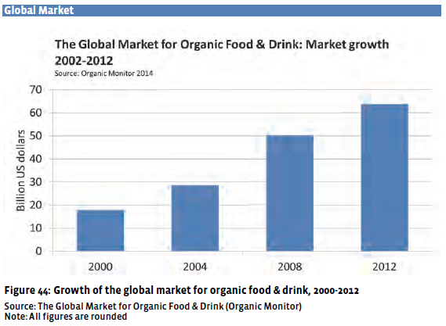

**Rice market**

**Import**

On the demand side, a higher import is concerned in the countries which consume rice a primary food, which are Bangladesh, China, Malaysia, Philippines and Sri Lanka. Those countries are all gauge to have larger numbers of trading. In other hand, some African countries namely for Angola, Guinea, Kenya, Mozambique, Nigeria and Senegal estimate to show higher in import

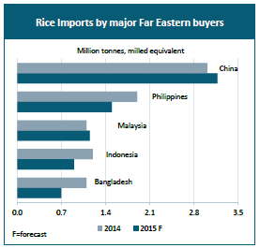

In Far East Asia estimated to be dropped because at both Indonesia and Philippines will cut the import because of good prospect for ongoing harvest, while Sri Lankais predicted to slash its purchases from 600 000 ton in 2014 to a more normal level of 150 000 ton, this reduction is also facilitated by reinstatement of import duties. Timor Leste who raise the purchase in 2014 will also cut their import too in result of the local supply have been improved. In contrary, import in China expected to remain strong, as high local quotations continue to encourage traders to rely on cheaper of rice from abroad. Official flows to the country are currently seen rising to a total 2.7 million ton in 2015.

FAO made the forecasting about the number of import and stated that Africademand will step up by 410 000 ton into 14.5 million ton, this representing for 34% of global imports. At a sub-regional level*,* however, West African countries may reduce imports by 2 percent to 8.9 million ton, after sufficient availabilities were accumulated from the 2014 fast pace of purchases.

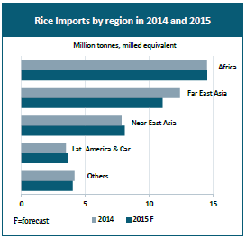

**Export**

FAO made forecast about the world rice trade in 2015 will fall around 2%. The highest drop prediction is coming from India, especially demand from the main consumer is projected to shrink. This because most countries in Asia expected to have promising harvest result in the next year, hence the export number will slightly decrease.

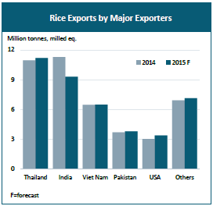

The high amount of money associated with the organic product, and its number always increase significantly each year even though the world suffered economic crisis in 2008. Moreover the global rice trading for export and import is quite steady. So we can conclude that rice has a great market, in addition the enthusiasm of organic product is growing, as the result organic brown rice possess a promising market.

Source:

FAO 2015

The World of Organic Agriculture, Statistic and Emerging Trends 2014. FiBL and IFOAM